**Implementing-CRM-for-Result-tracking-of-a-candidate-with-internal-marks**

# INTRODUCTION: -

## 1.1 Overview

Administrator should be able to create all base data including Semester, Candidate, Course and Lecturer. Lecturer should have the ability to create Internal Result. Dean, who is one of the Lecturer, should be the only one with ability to update Internal Result, Re-evaluation can be initialized by candidate for all Internal Result. Now only dean can update the marks after re-evaluation.

## 1.2 Purpose: -

It aims to produce areal time knowledge of the salesforce and how can we build a app using salesforce in this project we build a Candidate results card application for educational institutions, which would be useful for the staffs to reduce time and track the performance of the students with ease. It is helpful to have large number of data maintained under one platform.

# Problem Definition and Design Thinking: -

## Empathy Map

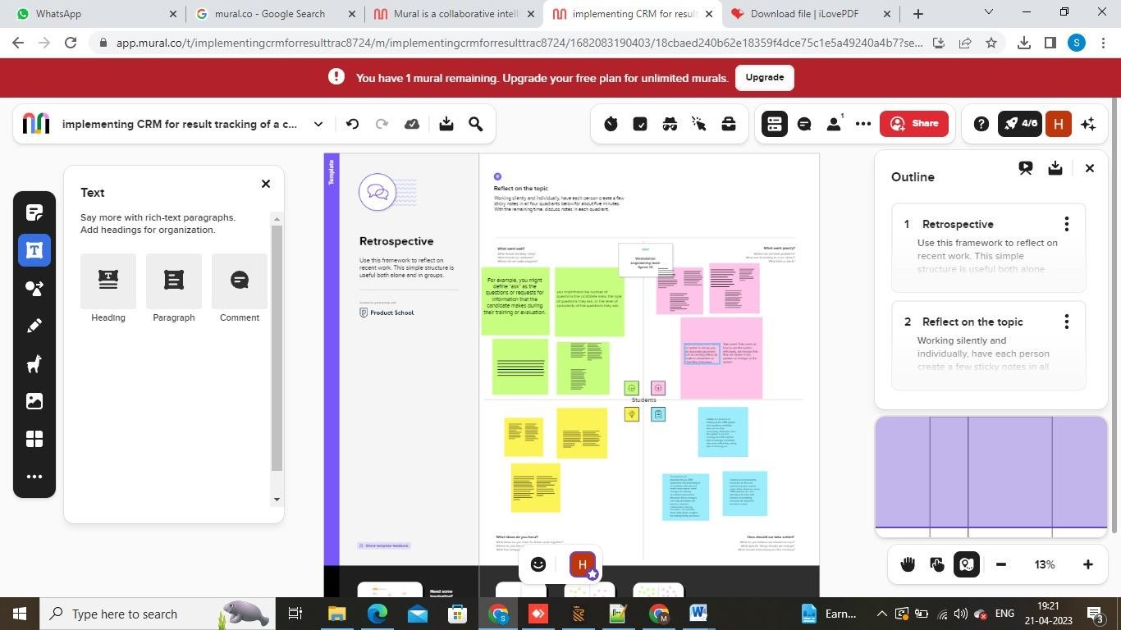

**2.2 Ideation and Brainstorming map Screenshot:**

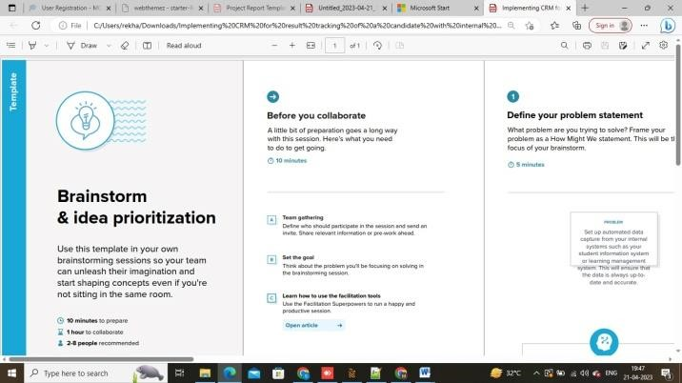

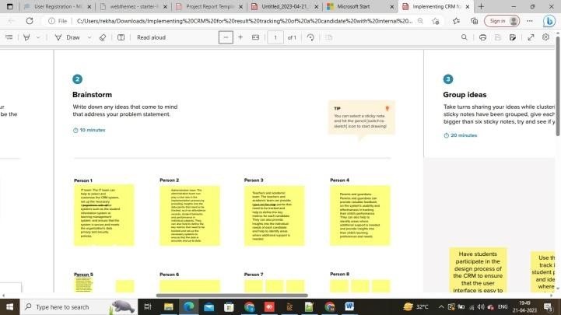

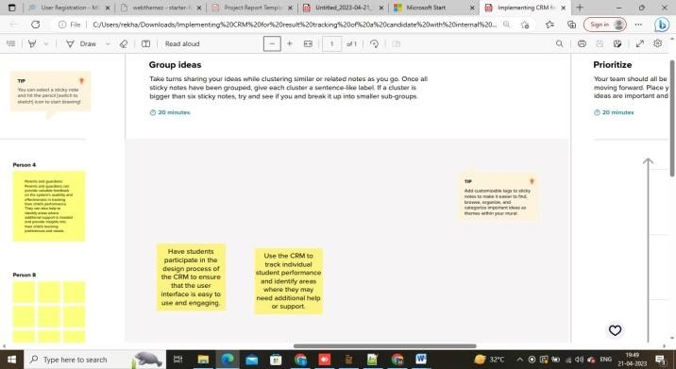

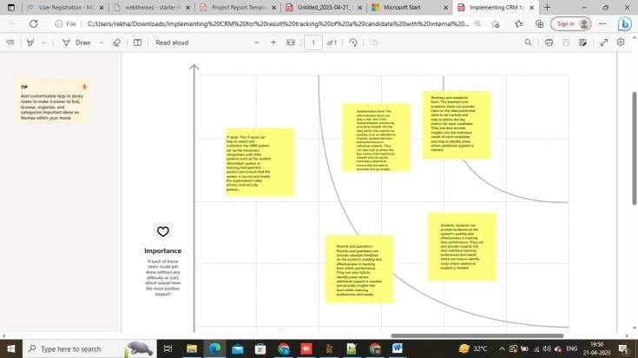

# RESULT: -

**3.1 Data Model:**

|  |  |
| --- | --- |
| **OBJECT NAME** | **FIELDS IN THE OBJECT** |
| **SEMESTER** | Field Label:  Semester Name  Course (Lookup)  Data Type:text |
| **CANDIDATE** | Field Label:  Candidate Name  Candidate Id  Semester Name  Internal results (lookup)  Data Type:text |
| **COURSE DETAILS** | Field Label:  CourseName  Course ID  Data Type:text |
| **LECTURER DETAILS** | Field Label:  Lecturer Role  Lecturer Name  Course ID  Course (Lookup)  Data Type:text |
| **INTERNAL RESULT** | Field Label:  Candidate Id  Course ID  Marks  Data Type:text |

## Activity and Screenshot: -

### CREATE A DEVELOPER ORG CREATION

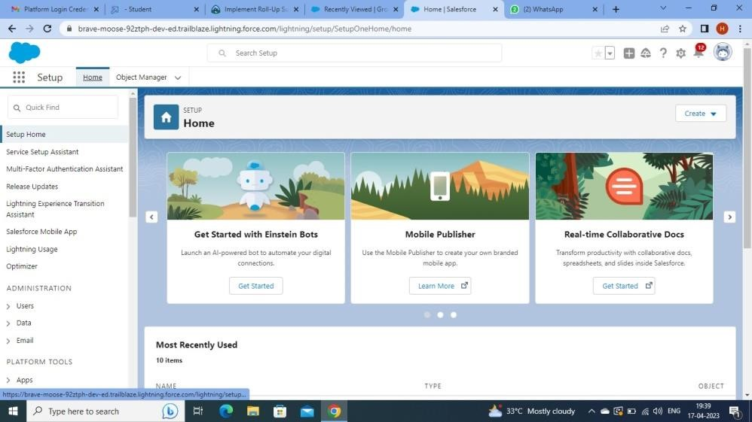

We have created an developer account for salesforce account salesforce is your customer success platform.

Our mail id and name or given to get developer account.

### To Create an object

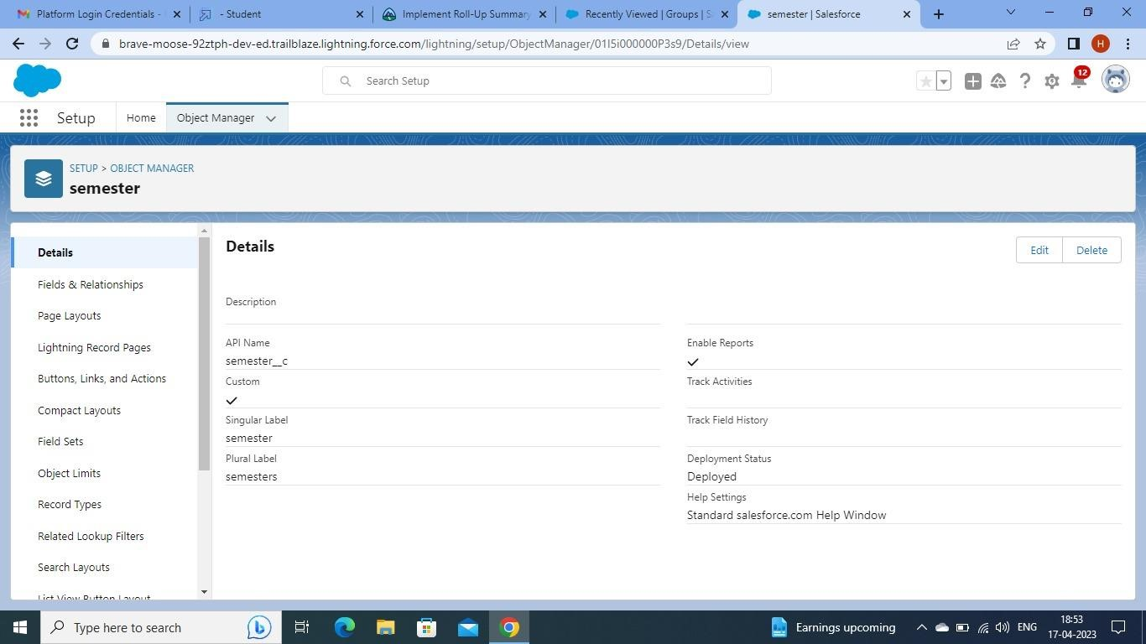

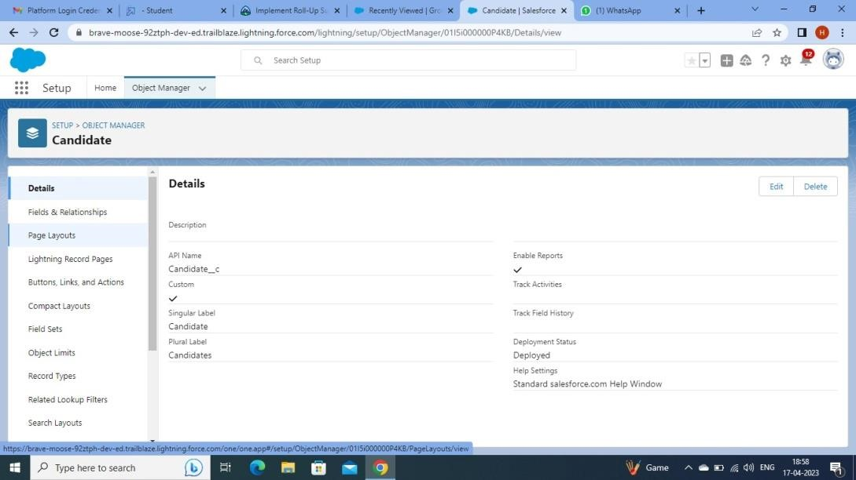

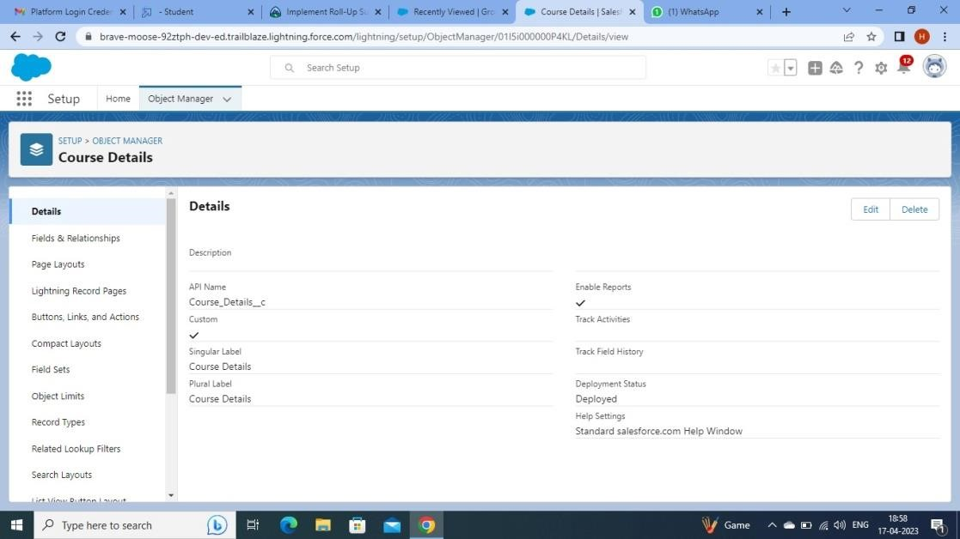

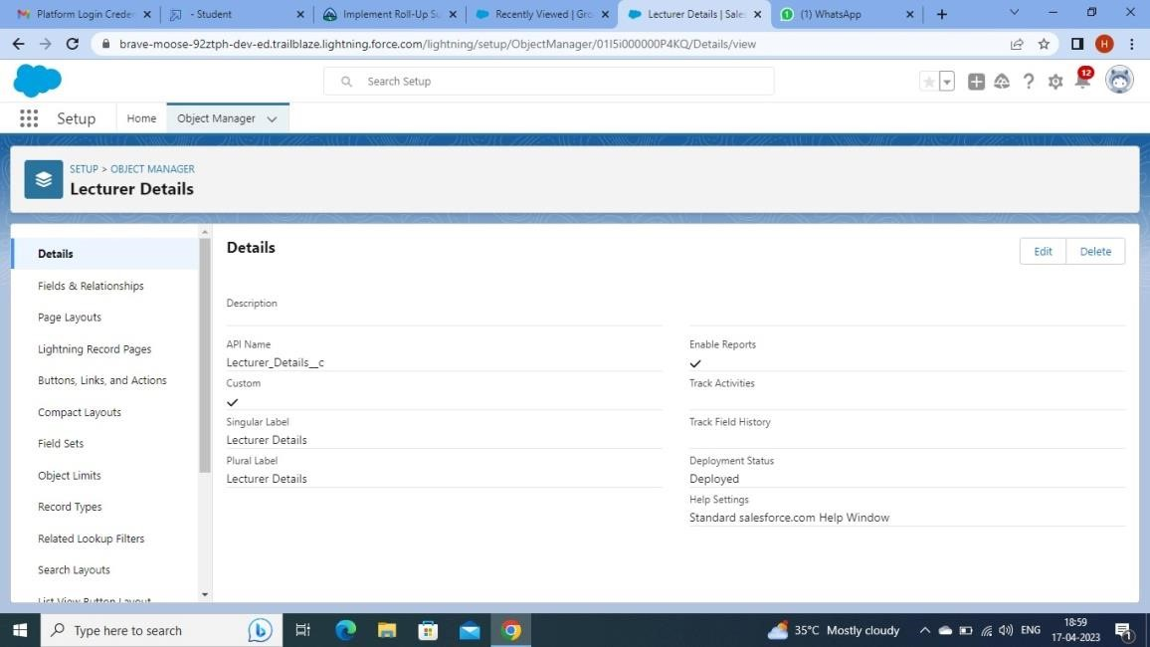

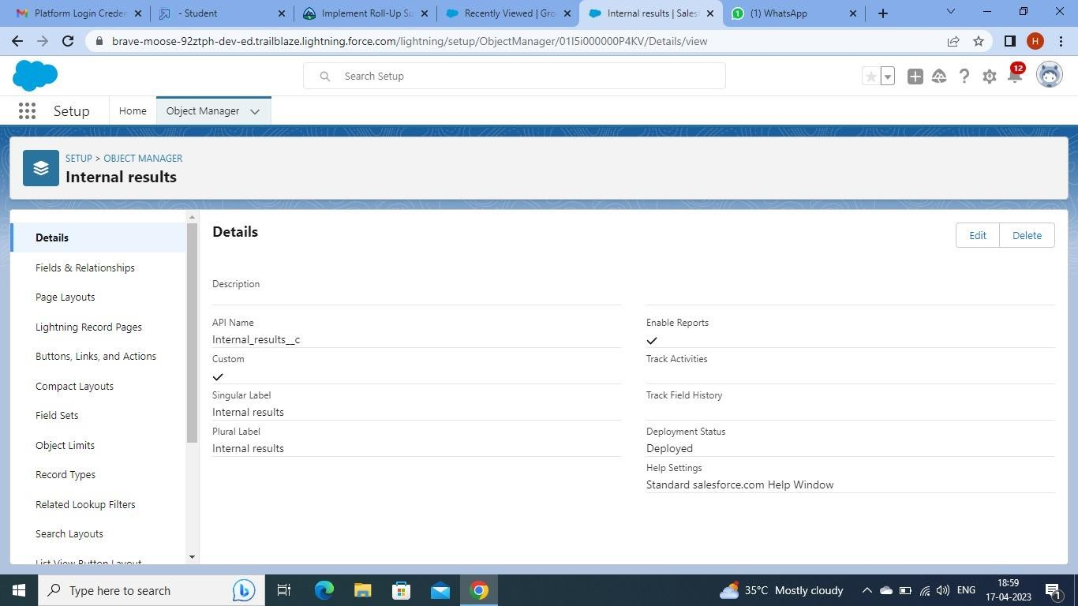

### Creation of fields

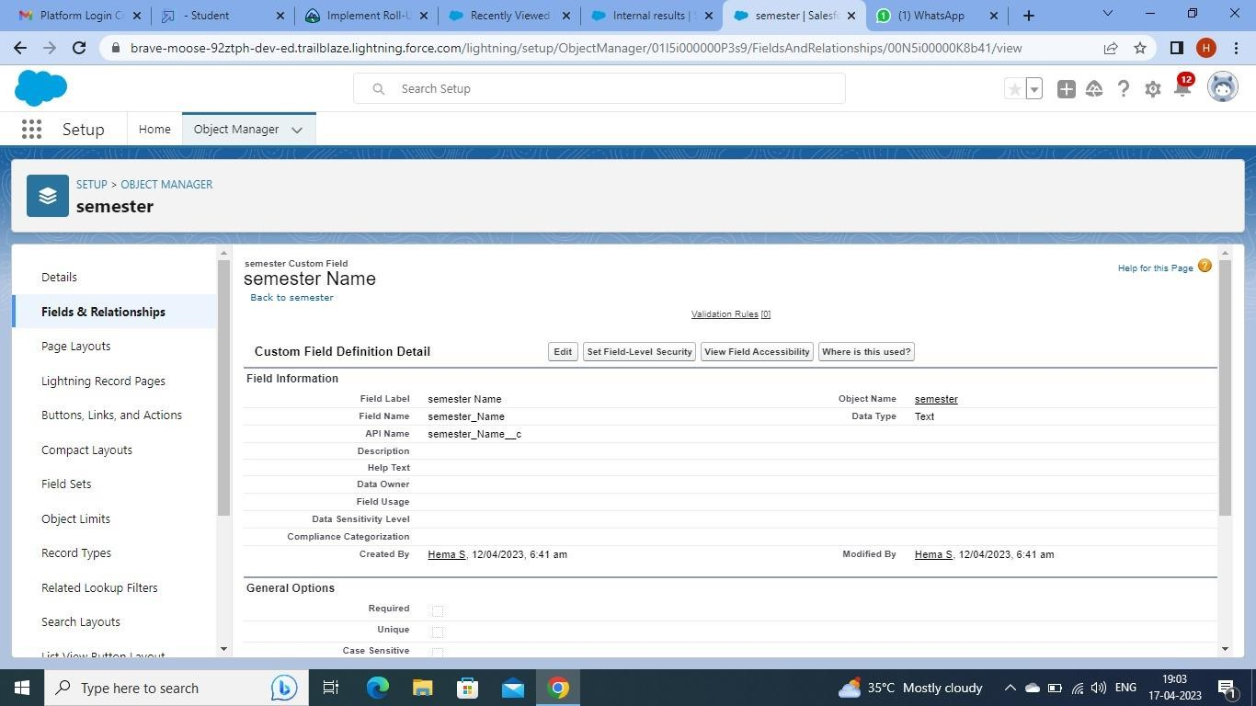

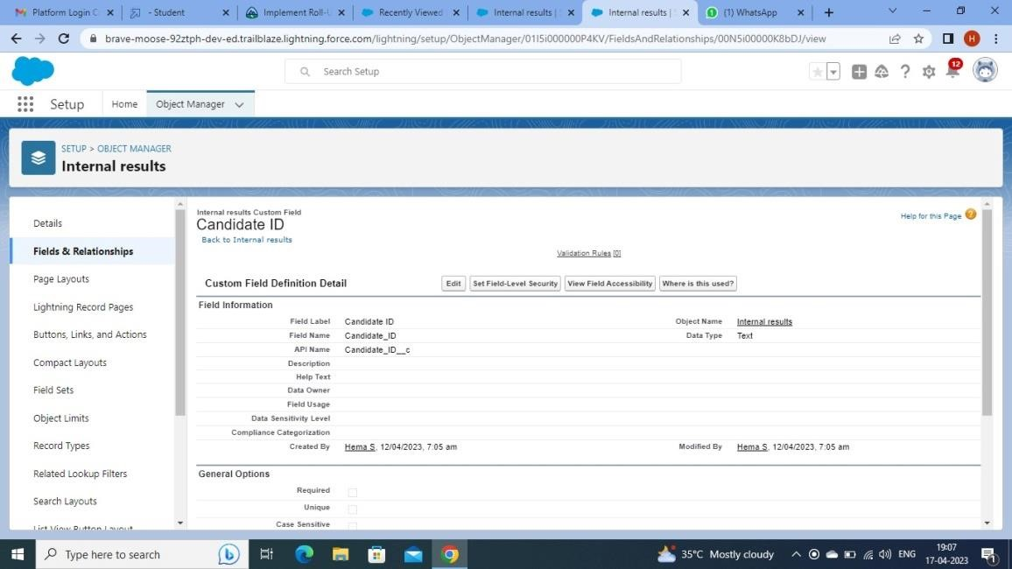

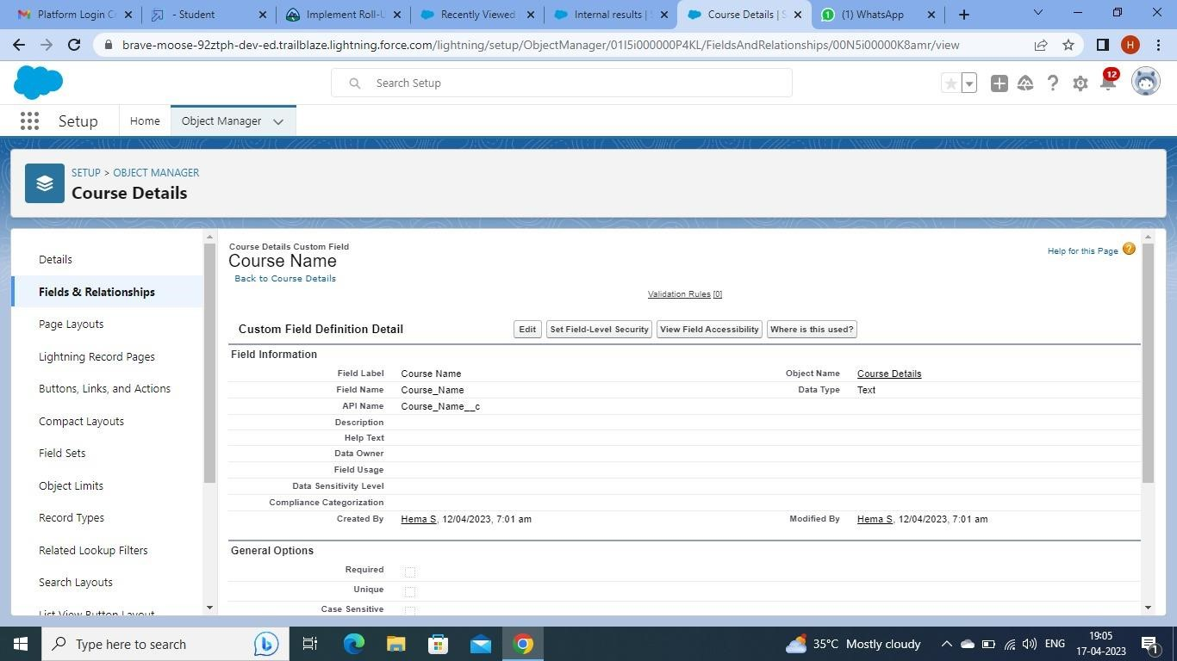

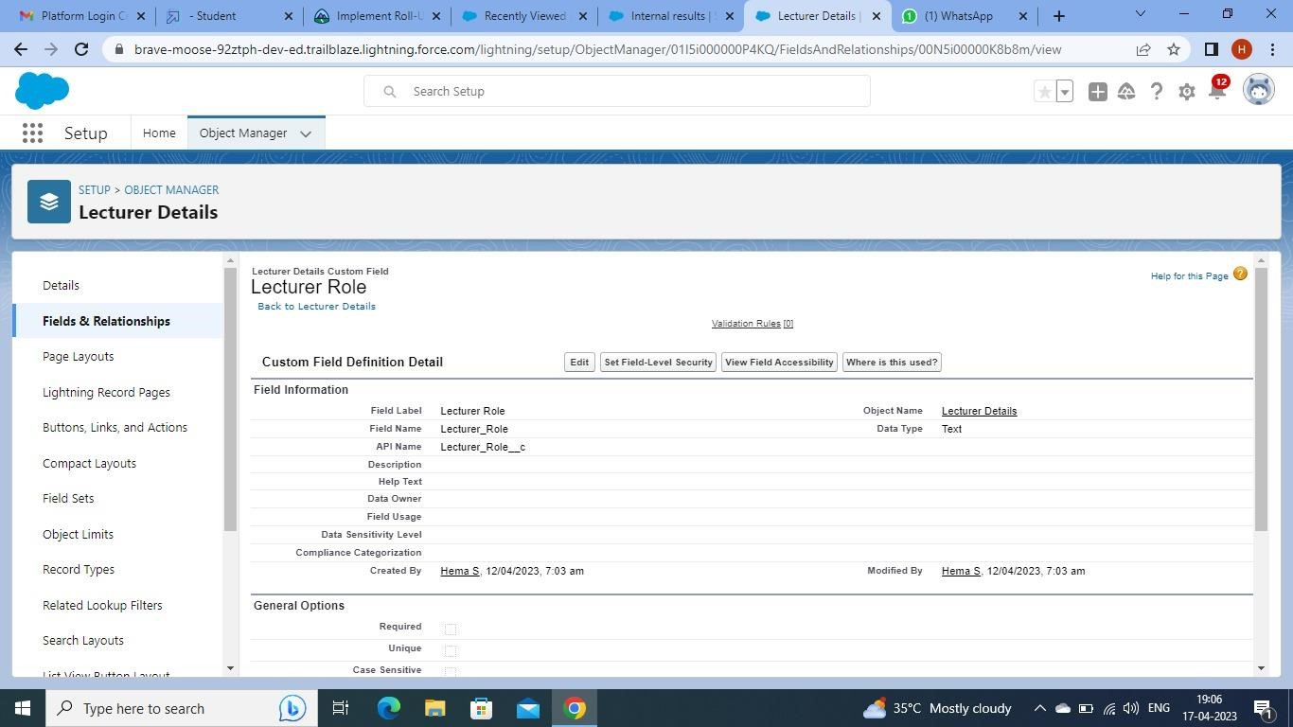

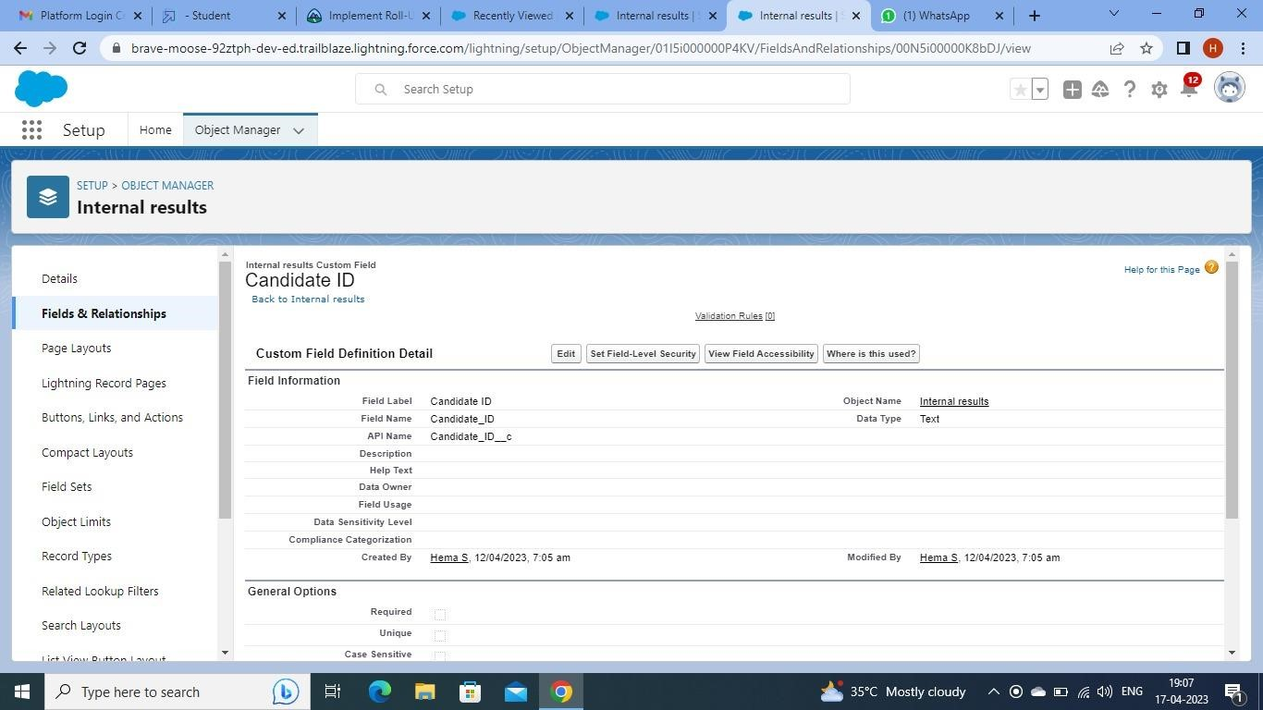

# Lighting App

## Creation the candidate Internal Result card app

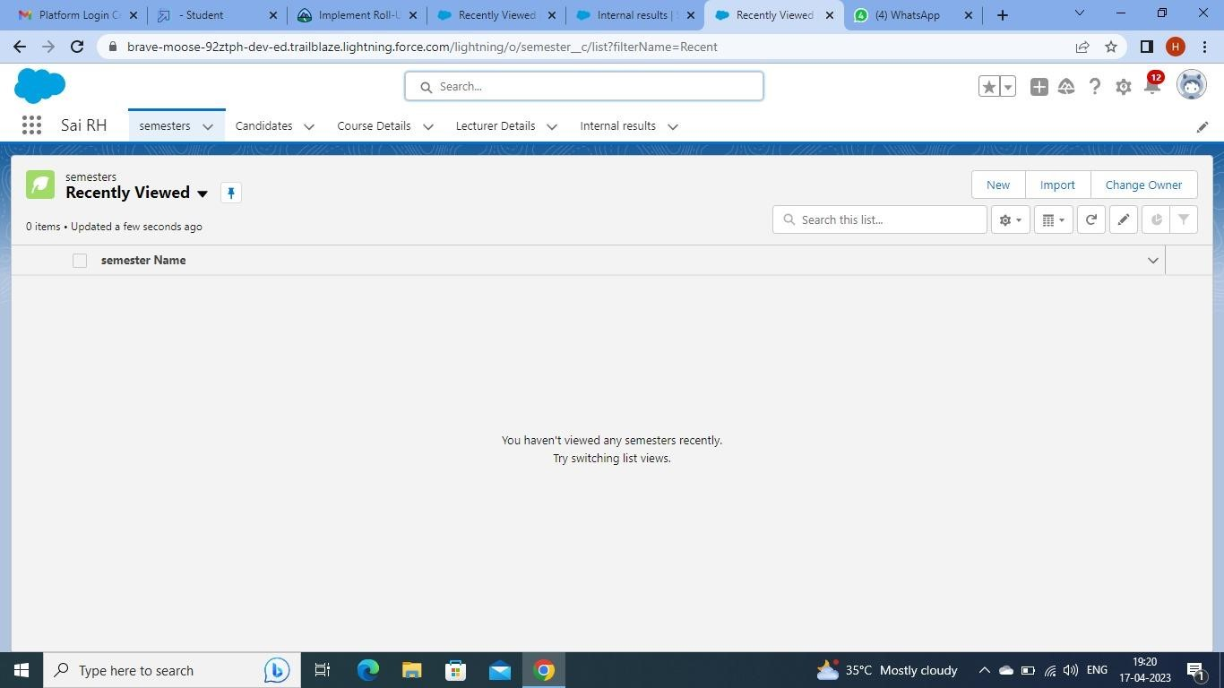

# Users

## Create a users

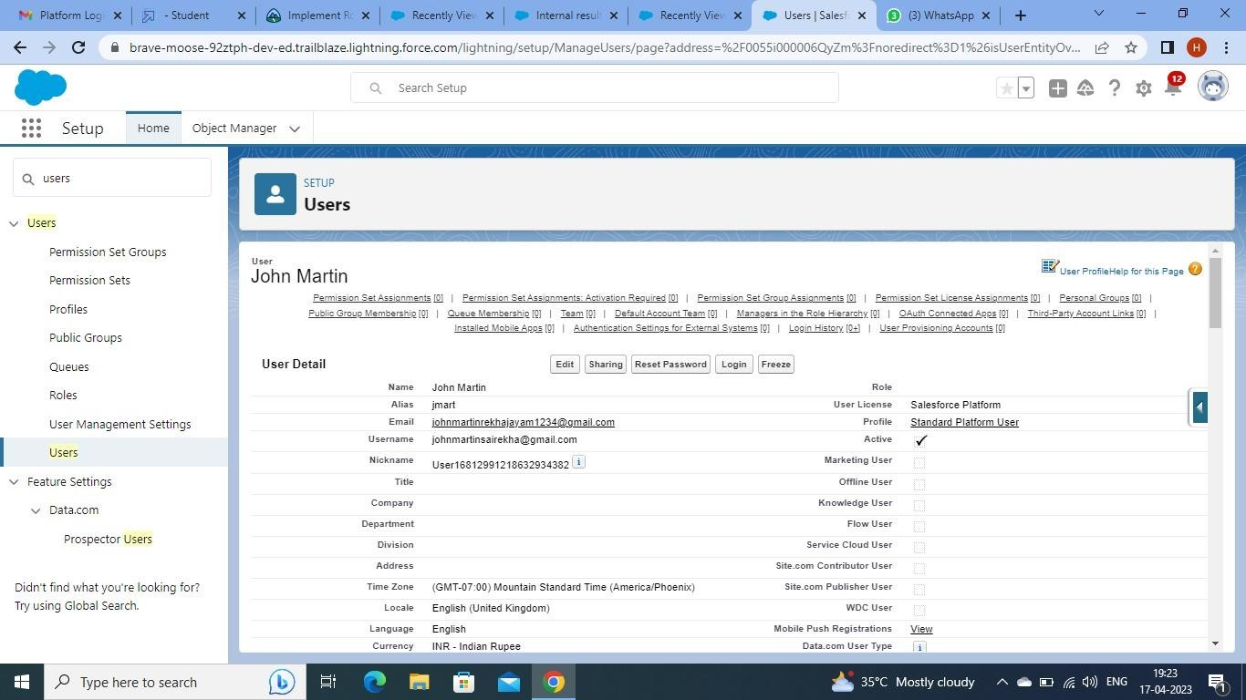

# Dashboards

## Create a Dashboard

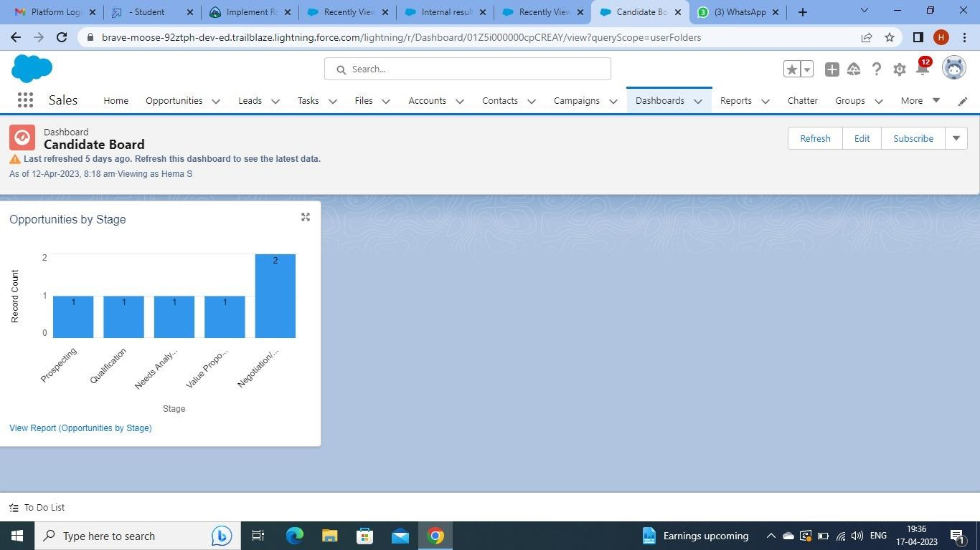

# Trailhead Profile public URL

**Team Lead-**  https://www.salesforce.com/trailblazer/jchandana2

**Team member 1**[**-**](https://trailblazer.me/id/kkanchi7) https://www.salesforce.com/trailblazer/kshaik214

**Team member 2**[**-**](https://trailblazer.me/id/gbanu15) https://www.salesforce.com/trailblazer/gpydi3

**5. ADVANTAGES & DISADVANTAGES:**

## Advantages

It helps teachers keep track of student performance used to study there progress throughout the course or degree.

Implementing CRM in result tracking with internal marks will help you streamline this process.

CRM systems provide real-time numbers, graphs and data that may be useful in decision making.

It also enables as to perform a search by keyword, sign documents digitally and send documents digitally.

## Disadvantages

1. Software subscription or purchase fees
2. Premium upgrades, eg add-on marketing or reporting features
3. Customization
4. IT resources needed
5. Hardware or software requirements
6. Staff training and upskilling

**APPLICATION:**

Implementing CRM in result tracking can be used in all educational institutions to track candidate results.

It can be used both in schools and colleges.

It schools, college even in universities, it would be very useful in monitoring students performance and records.

**CONCLUTION:**

* Educational institutions deal with lots of test paper and student evaluation.
* It is a painstaking process for teachers to evaluate and keep track of student test and assessment.
* So we have came up with a solution known as implementing CRM in result tracking with Internal Marks.
* We have customized objects, fields and created Candidate Result card app in that app e create reports and customized dashboard showing marks of student as vertical bars.
* By this app we can show the students result in graphical representation which in easier to manage their results.

**FUTURE SCOPE:**

* **OMNICHANNEL DASHBOARDS:-**

Deeply integrates with social media, websites, cloud telephony, and other software to bring all queries to a unified dashboards.

* **AUTOMATIONS**

AL-powered bots, automated feedback or information form collection, and canned responses save time for your staff.